DSP In-Class Exercise “Fabric_AOI_2022”

Group 17

110522130 資工碩一 李信鋌

110526005 資工碩一 林季陽

The code we wrote and the corresponding result.

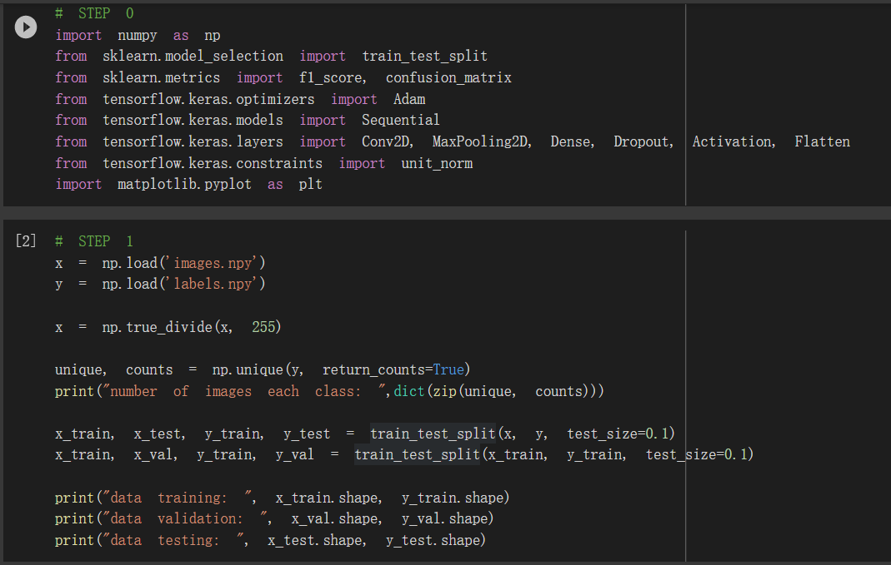

We split training dataset and testing dataset from the original dataset by using train_test_split function.

Then we split the validation set from training dataset by using train_test_split function.

These are the result.

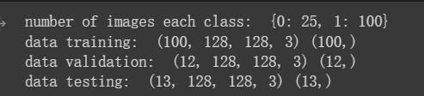

After preprocess and split the data, we build and compile the model.

Then we train the model using the training and validation data with epochs 10 and batch_size 32. (Underline with red lines)

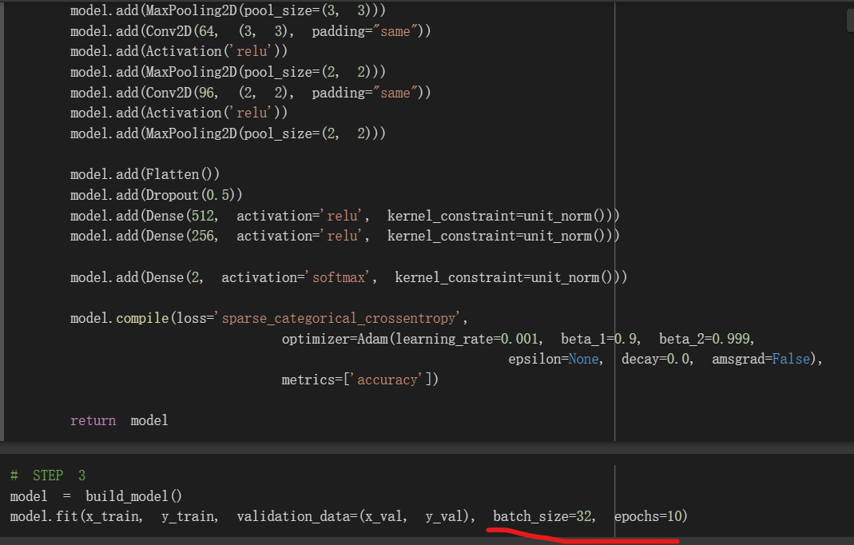

The image shows us the training loss, training accuracy, validation loss and validation accuracy respectively.

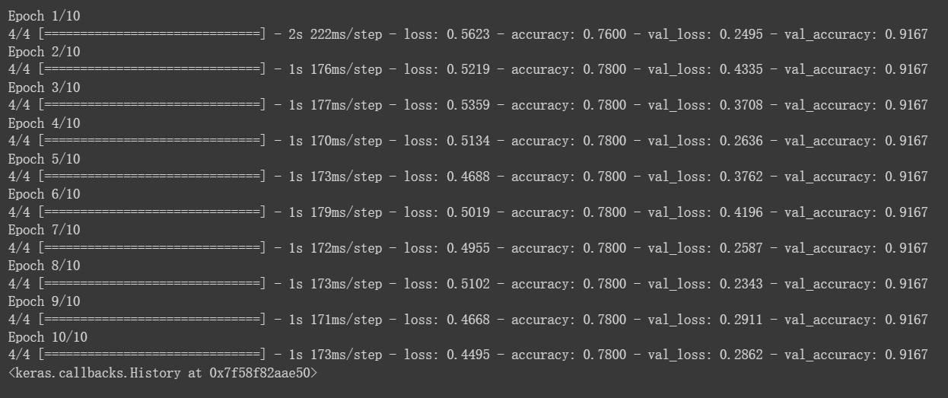

We produce confusion matrix and calculate the f1 score.

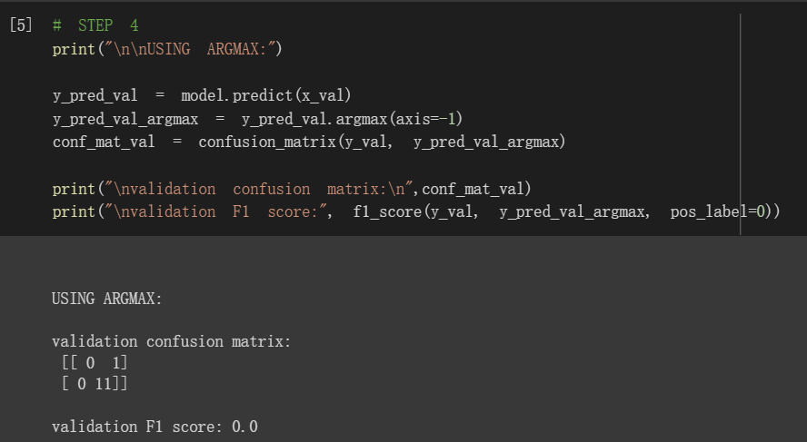

The first row of confusion matrix shows that there are zero defect images that are successfully detected, 1 of them is predicted as normal.

While the second row of confusion matrix shows that all normal class are successfully predicted as normal.

Since the F1 score does not take any true negative into account, the F1 score returns zero.

F1 scores calculation in multiple threshold values.

We predict the val image (y_pred_val) with predict function.

For each threshold value, the class is selected by comparing the threshold with the defect probabilities in the predicted val data

The process is followed by F1 score calculation of the class selection result with f1_score function

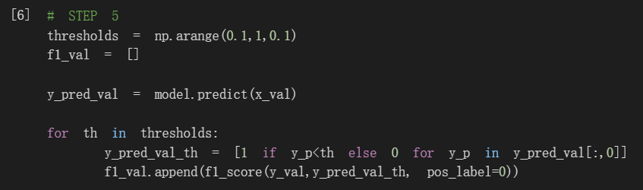

We select the best F1 scores from all threshold values

Plot F1 scores of the validation data with blue line

Plot the best F1 score of the validation data value with red “X” marker

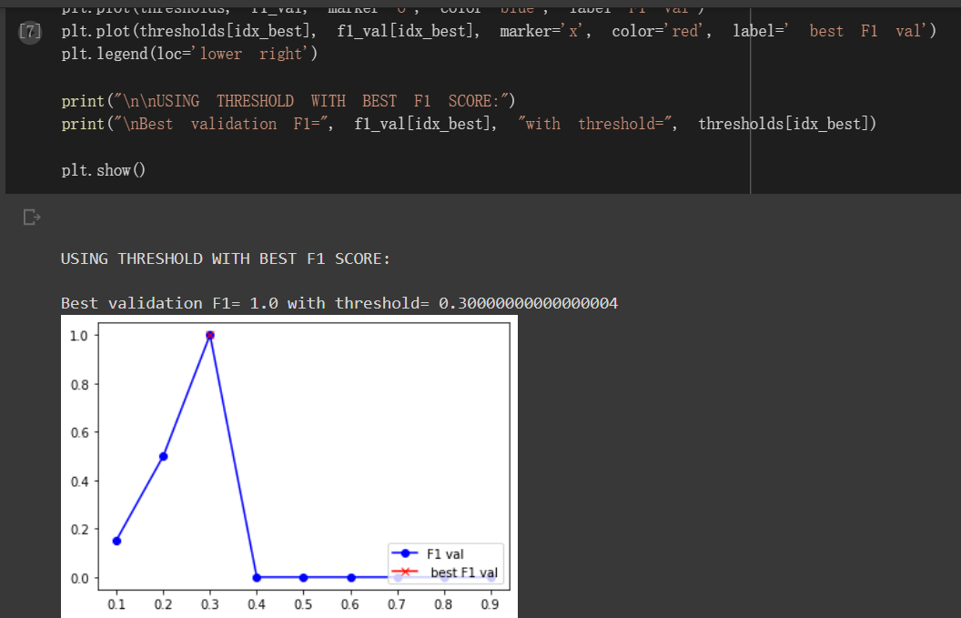

Highest F1 score (1.0) can be obtain with threshold=0.3000000….4 in step 6.

However, 0 F1 score can be obtain in step 4.

It shows the importance of implement multiple threshold selection.

We repeat the code in step 4 with multiple threshold selection.

F1 score improved to 1.0 after the selection.

